BSSE FINAL PROJECT
YUM
(A Mobile Application)



Project Advisor:
Dr. Ghulam Ali
Presented by:

F20-BSSE-5048 Aziz ur Rehman
F20-BSSE-5017 Abdul Rehman
F20-BSSE-5034 Wajid Ali Sher

Department of Software Engineering
Faculty of Computing

University of Okara
DECLARATION
We hereby declare that the project entitled “YUM” submitted by us to the University of Okara in partial fulfillment for the award of the degree BSSE (Software Engineering) is a record of bonafide work carried out by us under the supervision of Dr. Ghulam Ali, Faculty of Computing, University of Okara. We further declare that the work reported in this project has not been submitted and will not be submitted elsewhere for any other purpose or degree.

--------------------------------------

Aziz Ur Rehman
F20-BSSE-5048

--------------------------------------

Abdul Rehman
F20-BSSE-5017

---------------------------------------

Wajid Ali Sher
F20-BSSE-5034

CERTIFICATE
It is certified that the project titled “YUM” by Aziz Ur Rehman , Abdul Rehman , & Wajid Ali Sher Roll No. F20-BSSE-5048, F20-BSSE-5017, F20-BSSE-5034 respectively, under the supervision of Dr. Ghulam Ali, is fully adequate, in scope and in quality, as a final year project for the degree of Bachelor of Software Engineering.

Supervisor: -------------------------------
Dr. Ghulam Ali
Head of Dep. SE
UNIVERSTY OF OKARA

Project Coordinator: --------------------------------
Mr. Ahamd Nazir
Head of Dep. DS
UNIVERSTY OF OKARA

HOD/Chairperson: ----------------------------------
Dr. Ghulam Ali
Department of Computer Science
UNIVERSTY OF OKARA

Acknowledgment

All praise is to Almighty Allah who bestowed upon us a minute portion of His boundless knowledge by which we were able to accomplish this challenging task.
We are greatly indebted to our project supervisor “Dr. Ghulam Ali” for personal supervision, advice, valuable guidance, and completion of this project. We are deeply indebted to him for his encouragement and continual help during this work.
And we are also thankful to our parents and family who have been a constant source of encouragement for us and brought us the values of honesty & hard work.

--------------------------------------
Aziz Ur Rehman
F20-BSSE-5048

--------------------------------------
Abdul Rehman
F20-BSSE-503

---------------------------------------
Wajid Ali Sher
F20-BSSE-5034

Table of Contents
1. Introduction 1
1.1 Product 1
1.2 Scope 1
1.3 Business Goals 3
1.4 Document Conventions 4
1.5 References 6
2. Project Description 7
2.1 Overall Description 7
2.1.1 Product Features 7
2.1.2 User Classes and Characteristics 9
2.1.3 Operating Environment 13
2.1.4 Design and Implementation Constraints 16
2.1.5 Assumptions and Dependencies 20
2.2 Functional Requirements 23
2.2.1 Use-Case 1 23
2.2.2 Use-Case 2 (and so on) 25
2.3 Nonfunctional Requirements 34
2.3.1 Performance Requirements 34
2.3.2 Safety Requirements 37
2.3.3 Security Requirements 40
2.3.4 Software Quality Attributes 43
2.4 Other Requirements 45
3. Analysis Models 49
4. Design Models 49
5. Screenshots 56
6. Test Cases 63

Introduction

Product
The YUM app is a scalable, multi-purpose platform designed primarily for food delivery services. It consists of two main components: An End User App and a Restaurant App. Developed using Flutter for the frontend and Node.js for the backend, YUM aims to streamline the food ordering process for both consumers and restaurant owners. The app leverages MongoDB for efficient data management and offers a robust set of features, including user authentication, location services, product search, payment integration, and order notifications. YUM serves as a template for developers looking to create versatile and customizable food delivery applications.

Scope
The scope of the YUM app covered by this Software Requirements Specification (SRS) includes the development, deployment, and maintenance of a scalable food delivery platform consisting of an End User App and a Restaurant App. This SRS outlines the features, functionalities, and technologies utilized in the application, which are essential for providing a seamless user experience for both customers and restaurant partners.

Key Components:
- End User App:
  - User Authentication: Email and phone number verification.
  - Location Services: Automatic detection and use of user location for finding nearby restaurants.
  - Search and Discovery: Search functionality based on categories and user intent.
  - Order Management: Selection, placement, and tracking of orders.
  - Payment Integration: Secure payment options including Stripe and PayPal.
  - Notifications: Real-time updates on order status.
  - Account Management: Viewing order history, updating addresses, and deleting accounts.
- Restaurant App:
  - Order Processing: Receiving and managing orders from users.
  - Menu Management: Adding, updating, and removing menu items.
  - Notification System: Sending notifications to users about order status.
  - Account Management: Managing restaurant profile and settings.

Development Phases:
Initial Setup: Project creation, setup of screen utilities, and entry points.
UI Components: Development of bottom navigation bar, custom app bar, and reusable widgets.
State Management: Integration of GetX for efficient state management and controller implementation.
Core Features: Implementing user location services, category widgets, and product listings.
Payment and Notifications: Integration of payment gateways and notification systems.
Testing and Deployment: Thorough testing for functionality and deployment to appropriate platforms.

Future Enhancements:
Additional features, refinements, and optimizations based on user feedback and evolving requirements.
The YUM app aims to provide a comprehensive solution for food delivery services, ensuring ease of use, reliability, and scalability. This SRS will guide the development process, ensuring that all necessary features and functionalities are implemented to meet user needs and expectations.

Business Goals
- Enhance Customer Experience:
  - Provide a seamless and user-friendly interface for end users to order food from nearby restaurants efficiently.
  - Offer multiple authentication methods (email and phone verification) to ensure secure and easy access.
- Increase Restaurant Visibility and Sales:
  - Enable restaurants to reach a broader customer base by listing their offerings on the platform.
  - Facilitate order management, making it easy for restaurants to process and fulfill orders promptly.
- Streamline Order and Delivery Processes:
  - Implement efficient order management and real-time notification systems to keep users informed about their order status.
  - Integrate location services to optimize delivery routes and reduce delivery times.

- Expand Payment Options:
  - Integrate secure payment gateways such as Stripe and PayPal to offer multiple payment options, increasing convenience for users.
- Scalability and Flexibility:
  - Design the platform to be scalable, allowing for easy expansion to new markets or the addition of new features as needed.
  - Provide a customizable template that can be adapted for various business models within the food delivery industry.

- Data-Driven Insights:
  - Utilize data from user interactions and transactions to generate insights that can help improve service offerings and drive business decisions.
  - Provide restaurants with analytics on their sales and customer preferences to help them optimize their menus and marketing strategies.
- Increase Customer Retention and Loyalty:
  - Offer features like order history and personalized recommendations to enhance user engagement and encourage repeat business.
  - Implement a reliable notification system to keep customers informed and satisfied with their order experience.
- Ensure Regulatory Compliance:
  - Ensure the platform adheres to relevant data protection and privacy regulations to protect user information.
  - Implement features that comply with food safety and delivery standards to maintain a trustworthy service.
By addressing these business goals, the YUM app aims to provide value to both end users and restaurant partners, fostering growth and success for the platform in the competitive food delivery market.

Document Conventions
This Software Requirements Specification (SRS) document follows specific standards and typographical conventions to ensure clarity and consistency. The following conventions are used throughout the document:

Text Formatting
- Bold Text: Used to highlight section headings, key terms, and important concepts.
- Italicized Text: Represents external systems, user roles, or specific actions taken by the user.

Section Numbering
- The document is structured using a hierarchical numbering system to organize sections and subsections clearly (e.g., 1.1, 1.2, 1.3, etc.).

Lists
- Bulleted Lists: Used for itemizing features, functionalities, and non-sequential information.
- Numbered Lists: Used for step-by-step instructions, ordered tasks, and development phases.

Terminology
- "User": Refers to end users of the YUM app who are placing orders.
- "Restaurant Partner": Refers to users of the Restaurant App who manage orders and menu items.
- "System": Refers to the overall YUM application, including both the End User App and the Restaurant App.

References and Citations
- Internal references to other sections within the document are indicated using the section number (e.g., see Section 1.2).

Special Notations
- [TODO]: Indicates sections or items that require further information or development.
- NOTE: Provides additional context or important information relevant to the current section.

Diagrams and Figures
- All diagrams and figures are labeled with a figure number and title (e.g., Figure 1: System Architecture).
- Captions are provided below each diagram or figure for easy reference.
By adhering to these conventions, this SRS document maintains a consistent and professional appearance, making it easier for readers to navigate and understand the requirements and specifications of the YUM app.

References
The following references were used in preparing the content of this Software Requirements Specification (SRS) for the YUM app:
- Websites:
  - Flutter Documentation. (n.d.). Retrieved from https://flutter.dev/docs
  - Node.js Documentation. (n.d.). Retrieved from https://nodejs.org/en/docs/
  - MongoDB Documentation. (n.d.). Retrieved from https://docs.mongodb.com/
  - UI/UX Design.Retrieved from https://www.dbestech.com/tutorials/flutter-multi-vendor-app
- Other References:
  - GetX Documentation. (n.d.). Retrieved from https://pub.dev/documentation/get/latest/
  - Flutter hooks Documentation. https://pub.dev/documentation/flutter_hooks/latest/
  - Express.js Guide. (n.d.). Retrieved from https://expressjs.com/en/guide/

These references provide the foundational knowledge and technical details necessary for the development of the YUM app and ensure that the SRS is accurate and comprehensive.

Project Description

Overall Description

Product Features

2.1.1.1End User App Features
The YUM app offers a comprehensive set of features designed to facilitate a seamless food delivery experience for both end users and restaurant partners. The major features include:
- User Authentication:
  - Email Verification: Users must verify their email addresses to ensure secure access to their accounts.
  - Phone Number Verification: Phone numbers are verified to confirm the user's identity and facilitate order processing.
- Location Services:
  - Automatic Location Detection: The app uses GPS to detect the user’s current location to find nearby restaurants and shops.
  - Location-Based Recommendations: Provides recommendations based on the user's location to enhance convenience and relevance.
- Search and Discovery:
  - Category Search: Users can search for food and products based on predefined categories (e.g., cuisine type, meal type).
  - Intent-Based Search: Allows users to search for items based on their specific intentions or cravings.
  - Popular Items: Displays popular food items or products to help users discover trending options.

- Order Management:
  - Order Placement: Users can browse menus, select items, and place orders.
  - Order Tracking: Provides real-time updates on the status of the order from preparation to delivery.
  - Order History: Users can view their past orders for easy reordering or reviewing.
- Payment Processing:
  - Secure Payments: Integration with payment gateways like Stripe and PayPal for safe and flexible payment options.
  - Multiple Payment Methods: Supports various payment methods to cater to user preferences.
- Notifications:
  - Order Status Updates: Sends real-time notifications about the order status, including confirmation, preparation, and delivery updates.
  - Promotional Notifications: Notifies users of special offers, discounts, or promotions.
- Account Management:
  - Profile Management: Users can update personal information, including contact details and preferences.
  - Address Management: Users can save and manage multiple delivery addresses or use a default address.
  - Account Deletion: Users have the option to delete their accounts if they choose to discontinue using the app.

2.1.1.2Restaurant App Features
- Order Processing:
  - Order Receipt: Restaurants receive orders placed by users through the app.
  - Order Management: Capabilities to view, update, and manage incoming orders to ensure timely preparation and fulfillment.
- Menu Management:
  - Menu Updates: Restaurants can add new items, update existing ones, and remove items from their menu.
  - Price Management: Allows restaurants to adjust pricing for menu items as needed.
- Notification System:
  - Order Notifications: Sends updates to users about the status of their orders.
  - System Alerts: Notifies restaurant staff about important events or system updates.
- Account Management:
  - Profile Management: Restaurants can manage their profiles, including operational details, contact information, and business hours.
  - Settings Management: Provides access to various settings related to the app’s functionalities and integration.
These features are designed to make the food ordering and delivery process as smooth and efficient as possible, enhancing the overall user experience for both consumers and restaurant partners.

User Classes and Characteristics
The YUM app caters to several distinct user classes, each with unique characteristics and requirements. Understanding these user classes helps tailor the app’s features and functionalities to meet their specific needs. Here are the primary user classes for the YUM app:

2.1.2.1End Users
- Frequency of Use:
  - Regular or Occasional: End users may use the app frequently for placing orders or occasionally for special occasions. Their engagement level can vary based on their needs and preferences.

- Subset of Functions:
  - Core Functions: End users primarily interact with the app's front-end features, such as browsing restaurant menus, searching for food, placing orders, making payments, and managing their account settings. They do not access backend management or administrative functions.
- Technical Expertise:
  - Moderate: End users are expected to have basic familiarity with mobile apps and online ordering systems. They should be comfortable navigating the app and performing common actions like searching and ordering.
- Security Levels:
  - Basic Security: End users need basic security for personal data protection, including secure login mechanisms and encrypted payment transactions. Their data privacy is crucial, but they do not access sensitive backend data.
- Educational Level:
  - Varied: End users come from diverse educational backgrounds. The app should be user-friendly and intuitive to accommodate users with varying levels of education and tech proficiency.
- Experience:
  - Varied: Includes both tech-savvy individuals and those less familiar with technology. The app should be designed to be accessible to users with different levels of experience, ensuring ease of use for all.

2.1.2.2 Restaurant Partners
- Frequency of Use:
  - Regular: Restaurant partners use the app regularly to manage their daily operations, including receiving and processing orders, updating menu items, and handling customer communications.

- Subset of Functions:
  - Core Functions: Restaurant partners interact with features related to order management, menu updates, and notifications. They may also manage their restaurant profile and settings.
- Technical Expertise:
  - Varies: Restaurant staff may have varying levels of technical expertise. Some may be familiar with digital tools and systems, while others might require additional training. The app should be designed to be user-friendly, with support resources available.
- Security Levels:
  - Higher Security: Restaurant partners need access to sensitive business information and transaction details. The app must ensure secure handling of data and financial transactions, with appropriate access controls to protect business and customer information.
- Educational Level:
  - Varied: Typically includes restaurant staff and managers with different levels of technical and educational backgrounds. Training and support should be provided to ensure effective use of the app.
- Experience:
  - Experienced: Generally includes individuals with experience in order management and restaurant operations. They may be familiar with point-of-sale systems but may need training specific to the app’s features.

2.1.2.3 System Administrators
- Frequency of Use:
  - Infrequent or As-Needed: System administrators use the app's backend tools and functions for maintenance, support, and system management. Their involvement is typically periodic or based on specific needs.

- Subset of Functions:
  - Administrative Functions: System administrators have access to system settings, user management, security configurations, and troubleshooting tools. They manage the overall health and functionality of the app.
- Technical Expertise:
  - High: System administrators require advanced technical skills for managing and maintaining the app’s infrastructure, security, and performance. They are responsible for system updates, monitoring, and troubleshooting.
- Security Levels:
  - Highest Security: Administrators have access to all system functions and sensitive data. They must follow strict security protocols to protect system integrity and user data.
- Educational Level:
  - Technical or IT Qualifications: Typically possess degrees or certifications in IT or related fields. They have specialized knowledge required for system administration and support.
- Experience:
  - Extensive: Experienced in system administration, including managing applications, security, and user support. They are familiar with technical challenges and solutions related to app management.

2.1.2.4 Support Staff
- Frequency of Use:
  - As-Needed: Support staff engage with the app as needed to assist users with issues or queries. Their use of the app is based on customer support requirements.
- Subset of Functions:
  - Support Tools: Support staff use tools and features related to customer support, such as resolving issues, managing user queries, and accessing user interaction data.
- Technical Expertise:
  - Moderate: Support staff need to understand common user issues and guide users effectively. They should be familiar with app functionalities and have problem-solving skills.
- Security Levels:
  - Moderate Security: Support staff access user support data but do not have access to sensitive backend functions. They need secure access to relevant support tools and information.
- Educational Level:
  - Varied: Includes customer service or support training. Educational backgrounds can vary, but support staff should have strong communication and problem-solving skills.
- Experience:
  - Customer Service Experience: Experience in customer support roles is important. Support staff should be adept at handling user issues and providing effective solutions.
Each user class has distinct characteristics and needs, which helps in tailoring the app’s features and functionalities to ensure a smooth and effective user experience across different roles.

Operating Environment
The YUM app is designed to operate seamlessly across various environments, ensuring compatibility and stability across different hardware and software platforms. Below are the details of the operating environment for both the End User App and the Restaurant App:

2.1.3.1 Hardware Platform
- Mobile Devices:
  - Smartphones: The app is optimized for use on modern smartphones, including both Android and iOS devices.
  - Tablets: The app is compatible with tablets, offering an enhanced user experience with a larger display.
- Server Hardware:
  - The backend services are hosted on cloud-based servers, ensuring scalability and reliability. The hardware specifications can vary based on the hosting provider and deployment needs.

2.1.3.2 Operating System and Versions
- End User App and Restaurant App:
  - Android:
    - Minimum Supported Version: Android 5.0 (Lollipop) and above.
    - Recommended Version: Android 8.0 (Oreo) and above for optimal performance.
  - iOS:
    - Minimum Supported Version: iOS 11.0 and above.
    - Recommended Version: iOS 13.0 and above for optimal performance.
- Backend Server:
  - Operating System:
    - Preferred: Linux-based systems (e.g., Ubuntu, CentOS) for hosting Node.js applications.
    - Alternative: Windows Server for environments where Linux is not preferred.

Software Components and Applications
- Backend Technologies:
  - Node.js: Server-side runtime environment for executing JavaScript code.
  - Express.js: Web application framework for Node.js used to build the RESTful API.
  - MongoDB: NoSQL database used for storing and managing application data.
- Frontend Technologies:
  - Flutter: Cross-platform framework for building the mobile applications (End User App and Restaurant App).
- Payment Gateways:
  - Stripe: For secure payment processing.
  - PayPal: For additional payment options and processing.
- Notification Services:
  - Firebase Cloud Messaging (FCM): For sending push notifications to users.
  - APNs (Apple Push Notification Service): For sending notifications to iOS devices.
- Geolocation Services:
  - Google Maps API: For location detection and mapping services.
  - Apple MapKit: For location services on iOS devices.

Other Software Components
- Development Tools:
  - Integrated Development Environments (IDEs):
    - Android Studio or Visual Studio Code for Flutter development.
    - Visual Studio Code or WebStorm for Node.js and Express.js development.
- Version Control:
  - Git: For source code management and collaboration.
  - GitHub or GitLab: For hosting and managing the code repositories.
- Continuous Integration and Deployment (CI/CD):
  - Jenkins, CircleCI, or GitHub Actions: For automated testing and deployment.
- Security and Monitoring:
  - SSL/TLS: For securing data in transit.
  - Monitoring Tools: Such as New Relic or Datadog for application performance monitoring.
The YUM app is designed to operate efficiently within this specified environment, ensuring compatibility with the necessary hardware, operating systems, and software components. This robust operating environment ensures that the app performs optimally and reliably for both end users and restaurant partners.

Design and Implementation Constraints
The development of the YUM app is subject to several design and implementation constraints, which limit the options available to developers. These constraints include corporate policies, hardware limitations, specific technologies and tools, security considerations, and design conventions. Below are the key constraints:

Corporate or Regulatory Policies
- Data Privacy Regulations:
  - GDPR Compliance: The app must comply with the General Data Protection Regulation (GDPR) for users in the European Union, ensuring data privacy and protection.
  - CCPA Compliance: For users in California, the app must adhere to the California Consumer Privacy Act (CCPA) requirements.
- Payment Processing Regulations:
  - Compliance with PCI DSS (Payment Card Industry Data Security Standard) to ensure secure handling of payment information.

Hardware Limitations
- Mobile Device Specifications:
  - The app must perform well on a wide range of mobile devices with varying specifications, including lower-end smartphones with limited processing power, memory, and storage capacity.
  - Optimization for different screen sizes and resolutions to ensure a consistent user experience across devices.

Specific Technologies, Tools, and Databases
- Technological Stack:
  - Frontend: The app must be developed using Flutter for cross-platform compatibility on Android and iOS devices.
  - Backend: The backend services must be built using Node.js with the Express.js framework.
  - Database: MongoDB must be used as the primary database for storing and managing application data.
- Payment Gateways:
  - The app must integrate with Stripe and PayPal for payment processing.
- Geolocation Services:
  - The app must utilize Google Maps API and Apple MapKit for location detection and mapping services.

Security Considerations
- Data Encryption:
  - All sensitive data, including user information and payment details, must be encrypted in transit and at rest.
- Authentication and Authorization:
  - Implement secure authentication mechanisms, including email and phone number verification.
  - Use robust authorization protocols to ensure that users and restaurant partners have appropriate access levels.
- Secure Development Practices:
  - Follow secure coding practices to prevent common vulnerabilities such as SQL injection, cross-site scripting (XSS), and cross-site request forgery (CSRF).

Conventions and Programming Standards
- Code Quality and Maintenance:
  - Adhere to industry-standard coding conventions and best practices to ensure code readability and maintainability.
  - Use version control (Git) to manage code changes and collaborate effectively.
- Testing and Quality Assurance:
  - Implement thorough testing procedures, including unit tests, integration tests, and end-to-end tests, to ensure the reliability and stability of the app.

Interfaces to Other Applications
- Third-Party APIs:
  - The app must interface seamlessly with various third-party APIs, including payment gateways (Stripe, PayPal), geolocation services (Google Maps API, Apple MapKit), and notification services (Firebase Cloud Messaging, APNs).
- System Integration:
  - Ensure compatibility and smooth integration with existing systems used by restaurant partners, such as point-of-sale (POS) systems and inventory management systems.

Language Requirements
- Programming Languages:
  - Frontend: Dart (used by Flutter) for developing the mobile applications.
  - Backend: JavaScript (Node.js) for developing the server-side application logic.
- Localization and Internationalization:
  - The app should support multiple languages to cater to a diverse user base, ensuring proper localization and internationalization.

Communications Protocols
- Networking:
  - Use HTTPS for secure communication between the client and server to protect data in transit.
  - Implement WebSocket or similar protocols for real-time communication features such as order status updates.

Design Constraints
- User Interface and Experience:
  - The app must provide an intuitive and user-friendly interface, ensuring a seamless user experience.
  - Follow design guidelines and principles to ensure a consistent look and feel across different platforms.
- Performance and Scalability:
  - Optimize the app for performance to ensure quick response times and efficient resource usage.
  - Design the backend architecture to support scalability, allowing the app to handle increasing loads and user growth.

2.2.4.1 Corporate Maintenance Responsibilities
- Support and Maintenance:
  - The customer’s organization will be responsible for maintaining the delivered software, including regular updates, bug fixes, and feature enhancements.
  - Ensure comprehensive documentation and training materials are provided to support ongoing maintenance and user training.
By adhering to these design and implementation constraints, the development of the YUM app will align with regulatory requirements, technological standards, and user expectations, ensuring a robust and reliable product.

Assumptions and Dependencies
The development and deployment of the YUM app are based on several assumptions and dependencies that could impact the project if they change or prove incorrect. These factors include third-party components, development and operating environments, and other external factors. Understanding these assumptions and dependencies helps manage risks and ensure smooth project execution.

Assumptions
- User Availability and Adoption:
  - Assumption: There will be a sufficient number of users (both end users and restaurant partners) willing to adopt and use the YUM app regularly.
  - Impact if Incorrect: Low user adoption could affect the app's success and revenue generation.
- Stable Internet Connectivity:
  - Assumption: Users will have access to stable and reliable internet connectivity to use the app effectively.
  - Impact if Incorrect: Poor connectivity could result in a suboptimal user experience and hinder app functionality.
- Third-Party Services:
  - Assumption: Third-party services (e.g., Stripe, PayPal, Google Maps API, Firebase) will remain stable and available.
  - Impact if Incorrect: Disruptions or changes in third-party services could affect payment processing, geolocation services, and notifications.
- Platform Support:
  - Assumption: Both Android and iOS platforms will continue to support Flutter and the necessary APIs without major changes that require significant rework.
  - Impact if Incorrect: Major changes in platform support could necessitate substantial modifications to the app, increasing development time and costs.

- Backend Infrastructure:
  - Assumption: The cloud infrastructure used for hosting the backend services will provide adequate performance, reliability, and scalability.
  - Impact if Incorrect: Insufficient infrastructure could lead to performance issues, downtime, and scalability problems.
- Legal and Regulatory Compliance:
  - Assumption: The app will comply with current legal and regulatory requirements (e.g., GDPR, CCPA).
  - Impact if Incorrect: Non-compliance could result in legal penalties and loss of user trust.

Dependencies
- Third-Party Components:
  - Dependency: The app relies on several third-party components and services, including:
    - Payment Gateways: Stripe and PayPal for payment processing.
    - Geolocation Services: Google Maps API and Apple MapKit for location detection and mapping.
    - Notification Services: Firebase Cloud Messaging (FCM) and Apple Push Notification Service (APNs) for sending push notifications.
- Development Tools and Libraries:
  - Dependency: The development environment depends on tools and libraries such as Flutter for front-end development, Node.js and Express.js for backend development, and MongoDB for the database.
  - Impact if Unavailable: If any of these tools or libraries become unavailable or deprecated, it could significantly impact the development process.
- Operating System Updates:
  - Dependency: Regular updates from mobile operating systems (Android and iOS) that may introduce changes affecting app functionality.
  - Impact if Incompatible: Incompatibilities due to OS updates may require timely app updates to maintain functionality.
- Server and Hosting Services:
  - Dependency: Reliable hosting services for the backend, typically provided by cloud service providers (e.g., AWS, Google Cloud, Azure).
  - Impact if Unreliable: Hosting service disruptions could affect app performance and availability.
- Data and Privacy Regulations:
  - Dependency: Compliance with data protection and privacy regulations (e.g., GDPR, CCPA).
  - Impact if Changes Occur: Changes in regulations could necessitate modifications to the app’s data handling and privacy policies.
- Market and Technological Trends:
  - Dependency: Trends in mobile app usage, food delivery market demands, and technological advancements.
  - Impact if Ignored: Failing to adapt to market trends and technological advancements could result in a competitive disadvantage.

Summary
The YUM app’s development is predicated on several assumptions and dependencies that influence its requirements and execution. Identifying and monitoring these factors is crucial for mitigating risks and ensuring the project's success. If any of these assumptions prove incorrect or dependencies change, the project plan, requirements, and timelines may need to be adjusted accordingly.

Functional Requirements

Use-Case 1
ID | UC1
Description | This use case involves the process of user authentication, including logging in and accessing account information.
Actors | User
Preconditions | The user must have a registered account with "Hometown Bites".
Basic Steps | User enters credentials (email/phone and password).  System validates the entered credentials.  Upon successful validation, the user accesses their account.  User can view and edit their profile information, change passwords, view order history, and track orders.
Alternate Steps | If the user forgets their password:  - User clicks on the "Forgot Password" link.  - System prompts the user to enter their email/phone associated with the account.  - User receives a password reset link/code via email or SMS.  - User clicks on the link or enters the code to reset their password.
Exceptions | If the entered credentials are incorrect, the system displays an error message and prompts the user to enter valid credentials.  If the user forgets their password, they can initiate a password reset process.
Business validations/Rules | Users must provide valid credentials to access their accounts.
Postconditions | User successfully accesses their account and can perform various actions within the application.

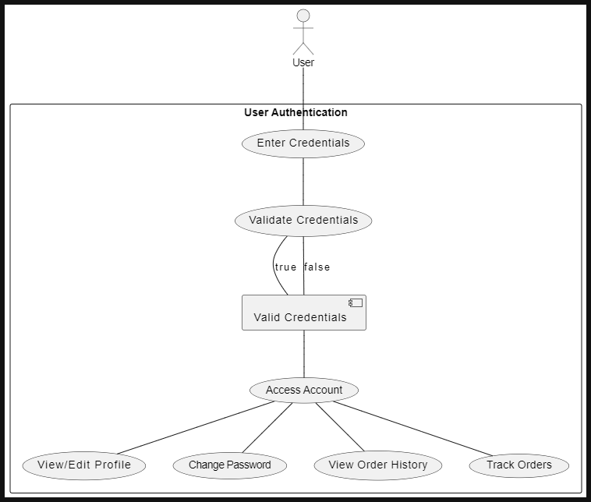

Use Case 2
ID | UC2
Description | This use case involves users browsing and searching for restaurants based on various criteria such as location, cuisine type, and ratings.
Actors | User
Preconditions | User successfully finds and views details of a restaurant.
Basic Steps | - User navigates to the restaurant browsing section.  - User filters or searches for restaurants based on criteria.  - System displays a list of restaurants matching the search criteria.  - User selects a restaurant from the list to view details.
Alternate Steps
Exceptions | - If the system encounters an error while retrieving restaurant data, it displays an error message to the user.
Business validations/Rules | - Restaurants are displayed based on proximity and relevance to the user's search criteria.
Postconditions | - User successfully finds and views details of a restaurant.

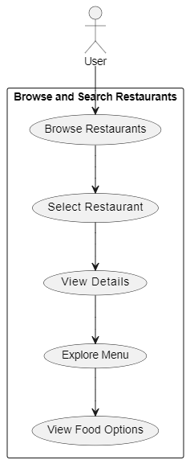

Use Case 3
ID | UC3
Description | This use case involves users adding food items from a selected restaurant to their shopping cart for purchase.
Actors | User
Preconditions | User has selected a restaurant and is viewing its menu..
Basic Steps | - User selects food items from the restaurant's menu.  - System adds the selected items to the user's shopping cart.  - User proceeds to view their shopping cart.
Alternate Steps
Exceptions | - If the selected food items are unavailable or out of stock, the system notifies the user.
Business validations/Rules | - Users can only add available food items to their shopping cart.
Postconditions | - Selected food items are successfully added to the user's shopping cart.
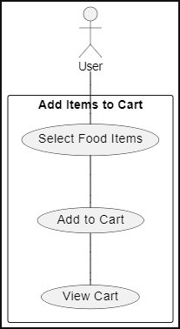

Use Case 4
ID | UC4
Description | This use case involves users placing an order for food items from a selected restaurant.
Actors | User
Preconditions | User must be logged in and have selected a restaurant.
Basic Steps | - User selects food items from the restaurant menu.  - User customizes food items (if applicable) and adds them to the cart.  - User reviews the order details and proceeds to checkout.
Alternate Steps
Exceptions
Business validations/Rules | - User must provide valid payment information to complete the order. Postconditions:
Postconditions | - Order is successfully placed, and the user receives a confirmation.
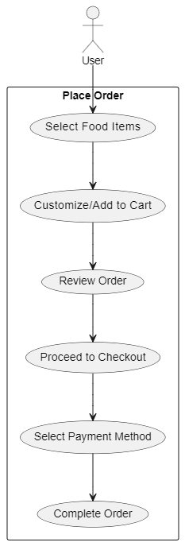

Use Case 5
ID | UC5
Description | This use case involves vendors managing their menu by adding, updating, and removing food items from their restaurant's menu.
Actors | Vendor
Preconditions | Vendor must be logged in and have access to the menu management section.
Basic Steps | - Vendor navigates to the menu management section.  - Vendor selects the option to add a new food item.  - Vendor provides details for the new food item, including name, price, description, and category.  - Vendor uploads images for the food item.  - Vendor saves the new food item to the menu.  - Vendor selects an existing food item to update.  - Vendor modifies the details of the selected food item, such as price or description.  - Vendor saves the changes to the updated food item.  - Vendor selects an existing food item to remove from the menu.  - Vendor confirms the deletion of the selected food item.
Alternate Steps
Exceptions | - If there are errors saving or updating the menu items, the system notifies the vendor and prompts them to retry.
Business validations/Rules | - Food items must have unique names within the menu.  - Only authorized vendors can access and manage the menu.
Postconditions | - Vendor successfully adds, updates, or removes food items from the menu.
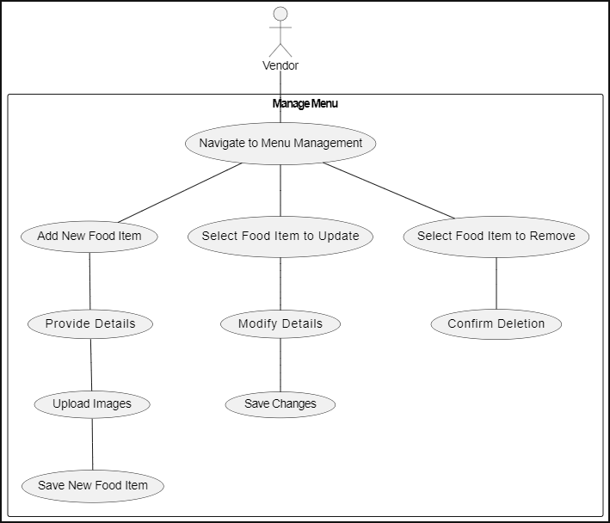

Use Case 6
ID | UC6
Description | This use case involves administrators managing restaurants on the platform, including verification, updates, and removals.
Actors | Admin
Preconditions | Admin must be logged in and have access to the restaurant management section.
Basic Steps | - Admin navigates to the restaurant management section.  - Admin views a list of restaurants awaiting verification.  - Admin verifies a restaurant by reviewing its details and confirming its authenticity.  - Admin views a list of existing restaurants on the platform.  - Admin selects an existing restaurant to update its details.  - Admin modifies the details of the selected restaurant, such as name, location, or contact information.  - Admin saves the changes to the updated restaurant.  - Admin selects an existing restaurant to remove from the platform.  - Admin confirms the removal of the selected restaurant.
Alternate Steps | - If the admin decides not to verify a restaurant, they can choose to reject it, providing a reason for rejection.
Exceptions | - If there are errors verifying, updating, or removing restaurants, the system notifies the admin and prompts them to retry.
Business validations/Rules | - Only authorized admins can access and manage restaurants.  - Verified restaurants must adhere to platform policies and guidelines.
Postconditions | - Admin successfully manages the verification, updates, and removals of restaurants on the platform.
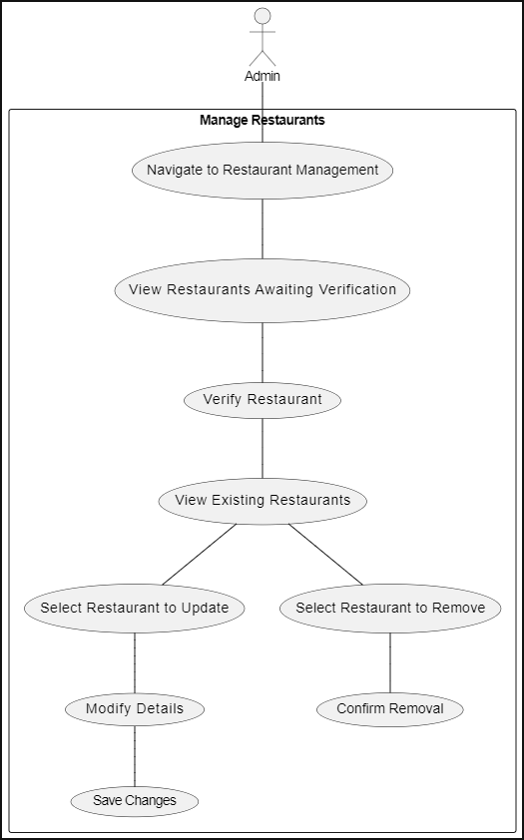

Nonfunctional Requirements

Performance Requirements
The performance requirements for the YUM app are critical to ensuring a smooth and responsive user experience under various circumstances. These requirements provide guidelines for developers to make appropriate design choices and optimize the app’s performance. Below are the specific performance requirements:

General Performance Requirements
- Response Time:
  - Requirement: The app should respond to user actions within 1 second for common interactions (e.g., opening a menu, viewing a product).
  - Rationale: Fast response times improve user experience and satisfaction.
- Page Load Time:
  - Requirement: The main pages of the app, such as the home screen and restaurant menus, should load within 3 seconds.
  - Rationale: Quick page load times are essential for keeping users engaged and reducing bounce rates.
- Transaction Processing:
  - Requirement: Payment transactions (e.g., Stripe, PayPal) should be processed within 5 seconds.
  - Rationale: Efficient transaction processing is crucial for user trust and smooth order completion.

Specific Performance Requirements
- User Registration and Login:
  - Requirement: User registration and login processes should be completed within 5 seconds after submitting the required information.
  - Rationale: Quick registration and login enhance user onboarding and retention.
- Location Services:
  - Requirement: The app should retrieve and display the user's current location within 2 seconds of granting permission.
  - Rationale: Accurate and timely location data is essential for providing relevant restaurant and delivery information.
- Search Functionality:
  - Requirement: Search results for restaurants and food items should be displayed within 2 seconds of initiating the search.
  - Rationale: Fast search results improve the user experience and help users find what they need quickly.
- Order Placement:
  - Requirement: The process of placing an order, from adding items to the cart to confirming the order, should be completed within 10 seconds.
  - Rationale: Streamlined order placement reduces friction and encourages users to complete their purchases.
- Notification Delivery:
  - Requirement: Push notifications for order updates should be delivered to the user within 1 second of the status change.
  - Rationale: Timely notifications keep users informed and engaged with the app.

2.3.1.3 Load and Stress Testing
- Concurrent Users:
  - Requirement: The app should support up to 10,000 concurrent users without significant performance degradation.
  - Rationale: Ensuring scalability is crucial for handling peak usage times, such as during promotions or peak dining hours.

- Server Response Time:
  - Requirement: The backend server should respond to API requests within 2 seconds under normal load and within 5 seconds under peak load.
  - Rationale: Consistent server response times are necessary for maintaining app performance and reliability.

Real-Time Requirements
- Real-Time Order Tracking:
  - Requirement: Real-time order tracking updates should be displayed within 1 second of receiving the data from the server.
  - Rationale: Accurate real-time tracking is essential for user satisfaction and trust in the delivery process.
- Live Chat and Support:
  - Requirement: Messages in live chat and support features should be delivered and displayed within 1 second.
  - Rationale: Fast communication improves the effectiveness of customer support and user satisfaction.

Resource Utilization
- CPU and Memory Usage:
  - Requirement: The app should optimize CPU and memory usage to ensure smooth performance on devices with limited resources.
  - Rationale: Efficient resource utilization enhances the app's performance and battery life on mobile devices.
- Data Usage:
  - Requirement: The app should minimize data usage, especially for users on limited data plans.
  - Rationale: Reducing data consumption improves the app's accessibility and user experience for those with data constraints.

Summary
By adhering to these performance requirements, the YUM app can deliver a responsive, reliable, and user-friendly experience. These guidelines help ensure the app performs well under various conditions and meets user expectations for speed and efficiency.

Safety Requirements
Safety requirements are essential to ensure that the YUM app is secure and protects users from potential harm, damage, or loss. These requirements address various aspects of safety, including data protection, secure transactions, and adherence to relevant policies and regulations.

Data Security
- Data Encryption:
  - Requirement: All sensitive user data, including personal information, payment details, and location data, must be encrypted both in transit and at rest using industry-standard encryption algorithms (e.g., AES-256).
  - Rationale: Encryption protects user data from unauthorized access and potential breaches.
- Secure Authentication:
  - Requirement: Implement multi-factor authentication (MFA) for user login and account management.
  - Rationale: MFA adds an extra layer of security, reducing the risk of unauthorized account access.
- Data Storage Compliance:
  - Requirement: Adhere to data protection regulations such as GDPR (for European users) and CCPA (for California users) regarding the collection, storage, and processing of personal data.
  - Rationale: Compliance with data protection regulations ensures that user data is handled legally and ethically.

Transaction Safety
- Payment Security:
  - Requirement: Payment transactions must be processed through secure and compliant payment gateways (e.g., Stripe, PayPal) with PCI-DSS compliance.
  - Rationale: Ensures that payment information is handled securely and reduces the risk of fraud and financial loss.
- Fraud Detection:
  - Requirement: Implement fraud detection mechanisms to identify and prevent suspicious transactions or activities.
  - Rationale: Protects users and the app from fraudulent activities and potential financial loss.

User Safety
- Privacy Protection:
  - Requirement: Clearly inform users about the types of data collected, its use, and obtain explicit consent before collecting personal data.
  - Rationale: Transparency in data collection practices helps build user trust and ensures compliance with privacy laws.
- Account Recovery:
  - Requirement: Provide secure methods for users to recover their accounts if they forget their passwords or lose access.
  - Rationale: Prevents unauthorized access while allowing legitimate users to regain access to their accounts.
- Emergency Contact:
  - Requirement: Allow users to quickly contact emergency services or customer support through the app in case of issues or emergencies.
  - Rationale: Enhances user safety by providing immediate assistance in critical situations.

External Policies and Regulations
- Compliance with Regulations:
  - Requirement: Ensure that the app complies with relevant regulations and standards such as GDPR, CCPA, and PCI-DSS.
  - Rationale: Compliance with these regulations is mandatory for legal operation and protects user rights.
- Third-Party Audits:
  - Requirement: Periodically undergo third-party security audits to assess and validate the app's security measures and practices.
  - Rationale: External audits provide an unbiased assessment of the app’s security posture and help identify potential vulnerabilities.

Safety Certifications
- PCI-DSS Certification:
  - Requirement: Obtain and maintain PCI-DSS certification for handling payment transactions.
  - Rationale: Certification demonstrates compliance with payment card industry standards and ensures secure handling of payment information.
- ISO 27001 Certification:
  - Requirement: Pursue ISO 27001 certification for information security management.
  - Rationale: ISO 27001 certification ensures that the app’s information security management system meets international standards.

Summary
The safety requirements for the YUM app focus on securing user data, ensuring safe transactions, protecting user privacy, and complying with relevant regulations and standards. By implementing these requirements, the app aims to safeguard users from potential harm, damage, or loss, and to provide a secure and reliable service.

Security Requirements
Security requirements are crucial to ensure the YUM app protects user data and maintains privacy while adhering to relevant regulations and standards. These requirements address various aspects of security, including data protection, user authentication, compliance with regulations, and necessary certifications.

Data Protection and Privacy
- Data Encryption:
  - Requirement: Encrypt all sensitive user data, including personal information, payment details, and location data, using strong encryption methods (e.g., AES-256) both during transmission and at rest.
  - Rationale: Encryption ensures data confidentiality and protects against unauthorized access.
- Data Minimization:
  - Requirement: Collect and store only the data necessary for the functionality of the app. Avoid excessive data collection.
  - Rationale: Reducing the amount of stored data minimizes the risk in case of a data breach.
- User Data Access:
  - Requirement: Implement strict access controls to ensure that only authorized personnel have access to user data. Use role-based access controls (RBAC) and least privilege principles.
  - Rationale: Protects user data from unauthorized access and misuse.
- Data Retention and Deletion:
  - Requirement: Establish clear policies for data retention and ensure timely deletion of user data when no longer needed or upon user request.
  - Rationale: Ensures compliance with data protection regulations and respects user privacy.

User Identity Authentication
- Multi-Factor Authentication (MFA):
  - Requirement: Implement multi-factor authentication (MFA) for user logins and sensitive actions within the app (e.g., account settings, payment transactions).
  - Rationale: MFA adds an additional layer of security, reducing the risk of unauthorized account access.
- Secure Password Storage:
  - Requirement: Store user passwords securely using hashing algorithms (e.g., bcrypt) and never store passwords in plain text.
  - Rationale: Protects user passwords from being exposed in case of a data breach.
- Session Management:
  - Requirement: Implement secure session management practices, including session timeouts and automatic logouts after a period of inactivity.
  - Rationale: Prevents unauthorized access if a user’s device is left unattended.

Compliance with Regulations
- Regulatory Compliance:
  - Requirement: Ensure compliance with relevant data protection regulations and privacy laws, such as:
    - General Data Protection Regulation (GDPR): For users in the European Union.
    - California Consumer Privacy Act (CCPA): For users in California, USA.
    - Payment Card Industry Data Security Standard (PCI-DSS): For handling payment information.
  - Rationale: Compliance with these regulations is required to legally operate and maintain user trust.

- Privacy Policy and User Consent:
  - Requirement: Provide a clear and comprehensive privacy policy that explains data collection practices, usage, and user rights. Obtain explicit user consent before collecting personal data.
  - Rationale: Transparency in data handling practices builds trust and ensures legal compliance.

Security Certifications
- PCI-DSS Certification:
  - Requirement: Obtain and maintain PCI-DSS certification for secure handling of payment transactions.
  - Rationale: Certification ensures adherence to security standards for processing credit card payments.
- ISO 27001 Certification:
  - Requirement: Pursue ISO 27001 certification for the information security management system (ISMS).
  - Rationale: ISO 27001 certification demonstrates adherence to international standards for managing information security.
- SOC 2 Certification:
  - Requirement: Obtain SOC 2 certification to validate controls related to data security, availability, processing integrity, confidentiality, and privacy.
  - Rationale: SOC 2 certification provides assurance of robust security practices and controls.

Summary
The security requirements for the YUM app focus on protecting user data, ensuring secure authentication, complying with relevant regulations, and achieving necessary security certifications. By implementing these requirements, the app aims to safeguard user privacy, maintain data integrity, and provide a secure and reliable service.

Software Quality Attributes
The YUM app’s quality attributes are essential for ensuring that the product meets user expectations and performs well under various conditions. These attributes address different aspects of software performance and maintainability, providing specific, quantitative, and verifiable criteria where possible.

Adaptability
- Requirement: The app should be able to integrate with third-party services (e.g., payment gateways, location services) with minimal modifications. Integration with new services should be achievable within 2 weeks.
  - Rationale: Ensures the app can evolve and integrate with new technologies as needed.

Availability
- Requirement: The app should achieve an uptime of 99.9% over a 12-month period, excluding planned maintenance.
  - Rationale: High availability ensures that users can access the app reliably.

Correctness
- Requirement: The app should have a bug density of less than 0.5 bugs per 1,000 lines of code. Critical bugs must be resolved within 48 hours of discovery.
  - Rationale: Ensures the app functions correctly and issues are addressed promptly.

Flexibility
- Requirement: The app's architecture should support adding new features with minimal changes to existing code. New feature integration should be possible within 3 weeks.
  - Rationale: Facilitates the addition of new functionalities without extensive redevelopment.

Interoperability
- Requirement: The app must be compatible with major mobile operating systems (iOS and Android) and their latest versions. Compatibility with new OS versions should be ensured within 1 month of their release.
  - Rationale: Ensures the app works seamlessly across different platforms and operating systems.

Maintainability
- Requirement: Code should adhere to established coding standards and best practices, with a codebase maintainability score of at least 80% according to standard metrics (e.g., SonarQube).
  - Rationale: Facilitates easier updates and maintenance of the codebase.

Portability
- Requirement: The app should be deployable on different cloud platforms (e.g., AWS, Azure) without significant changes to the deployment process.
  - Rationale: Ensures the app can be moved or hosted on various platforms as needed.

Reliability
- Requirement: The app should handle up to 10,000 concurrent users without performance degradation or crashes.
  - Rationale: Ensures the app remains stable under high load conditions.

Reusability
- Requirement: Components and modules within the app should be designed for reuse in other parts of the app or in future projects. Code reusability should be at least 60% according to internal metrics.
  - Rationale: Reduces development time and cost by reusing existing components.

Robustness
- Requirement: The app should gracefully handle and recover from unexpected errors or failures, with an error recovery rate of at least 95%.
  - Rationale: Ensures the app remains functional and user-friendly even in the face of unexpected issues.

Testability
- Requirement: The app should have automated test coverage of at least 70% for unit tests and 50% for integration tests.
  - Rationale: Ensures the app can be effectively tested and validated throughout its development.

Usability
- Requirement: The app should achieve a user satisfaction score of at least 80% in usability testing, with user interface (UI) elements designed for ease of use and minimal learning curve.
  - Rationale: Ensures a positive user experience and easy adoption of the app.

Summary
The software quality attributes for the YUM app focus on ensuring high performance, reliability, and user satisfaction. By defining specific, quantitative criteria for these attributes, the app aims to meet customer expectations, support ongoing development and maintenance, and deliver a robust and user-friendly product.

Other Requirements
This section outlines additional requirements for the YUM app that are not covered elsewhere in the SRS. These include database requirements, external interface requirements, internationalization needs, legal obligations, and objectives for reuse.

Database Requirements
- Database Scalability:
  - Requirement: The database must support horizontal scaling to handle increased data volume and user load. MongoDB should be configured for sharding and replication as needed.
  - Rationale: Ensures that the database can handle growth in users and data without performance issues.
- Data Backup:
  - Requirement: Implement automated daily backups of the database with retention for at least 30 days. Backup integrity should be verified regularly.
  - Rationale: Provides protection against data loss and facilitates recovery in case of a failure.
- Data Consistency:
  - Requirement: Ensure that data consistency and integrity are maintained across all database operations, using MongoDB’s built-in mechanisms for consistency.
  - Rationale: Prevents data corruption and ensures accurate information is stored and retrieved.

External Interface Requirements
- Payment Gateway Integration:
  - Requirement: Integrate with payment gateways (e.g., Stripe, PayPal) that comply with PCI-DSS standards. Provide secure API connections and handle responses appropriately.
  - Rationale: Ensures secure and reliable processing of payment transactions.
- Location Services:
  - Requirement: Integrate with location services APIs (e.g., Google Maps API) to provide accurate location data and support geocoding and routing functionalities.
  - Rationale: Enhances user experience by providing precise location-based services.
- Third-Party Services:
  - Requirement: The app should support integration with third-party services for additional functionalities, such as email notifications (e.g., SendGrid) and SMS messaging (e.g., Twilio).
  - Rationale: Expands the app’s capabilities and improves its functionality.

Internationalization Requirements
- Multi-Language Support:
  - Requirement: The app should support multiple languages for international users. Implement localization to allow for language selection and translation of app content.
  - Rationale: Provides a better user experience for non-English speaking users and supports global market expansion.
- Currency Localization:
  - Requirement: Implement support for multiple currencies, including currency formatting and conversion based on the user’s location.
  - Rationale: Facilitates transactions for users in different countries and regions.

Legal Requirements
- Privacy Compliance:
  - Requirement: Ensure compliance with privacy laws and regulations such as GDPR, CCPA, and any other relevant data protection laws. Include features for user data access and deletion requests.
  - Rationale: Adheres to legal obligations and protects user privacy.
- Terms of Service and Privacy Policy:
  - Requirement: Provide a clear and accessible Terms of Service and Privacy Policy within the app. Update these documents as needed to reflect changes in policies or regulations.
  - Rationale: Ensures users are informed about their rights and the app’s data handling practices.

Reuse Objectives
- Code Reusability:
  - Requirement: Design the app’s components and modules for reuse in future projects or applications. Follow coding practices that facilitate modularity and extensibility.
  - Rationale: Reduces development time and costs by enabling reuse of existing code.
- Component Libraries:
  - Requirement: Develop and maintain a library of reusable components and widgets that can be easily integrated into different parts of the app or other projects.
  - Rationale: Promotes consistency and efficiency in development by reusing established components.

Summary
The additional requirements for the YUM app address database management, external integrations, internationalization, legal compliance, and code reuse. These requirements ensure that the app is scalable, secure, and adaptable to various user needs and legal obligations while supporting efficient development and maintenance practices.

Analysis Models
This section includes the analysis models for the YUM app, which help in understanding the system’s functionality, data relationships, and interactions. The models provided are the use-case diagram, entity-relationship diagram, class diagram, and sequence diagram.

Use-Case Diagram
Purpose: The use-case diagram provides an overview of the functional requirements of the system, illustrating how different actors interact with the system and the various use cases they perform.
- Actors: End User, Restaurant, System Administrator.
- Use Cases:
  - End User: Register, Login, Search Food, Place Order, Make Payment, View Order History, Manage Account, Receive Notifications.
  - Restaurant: Register, Login, Update Menu, Process Orders, View Orders, Manage Account.
  - System Administrator: Monitor System Health, Manage Users, Manage Restaurants, Generate Reports.

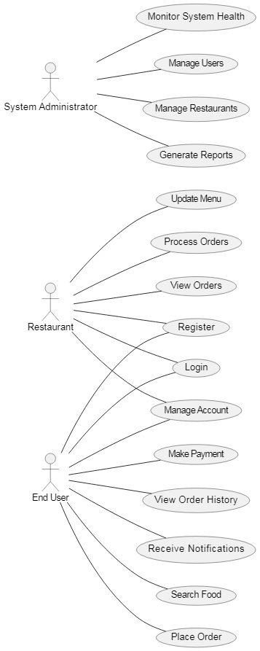

Usecase diagram of Analysis Model

Entity-Relationship Diagram (ERD)
Purpose: The ERD shows the data entities in the system and their relationships. It helps in designing the database schema.
Entities:
- User: UserID, Name, Email, Phone, Address, PasswordHash
- Restaurant: RestaurantID, Name, Location, ContactInfo, Menu
- Order: OrderID, UserID, RestaurantID, OrderDate, Status, TotalAmount
- MenuItem: ItemID, RestaurantID, Name, Description, Price
- Payment: PaymentID, OrderID, PaymentDate, Amount, PaymentMethod
Relationships:
- User places Order
- Restaurant processes Order
- Order contains MenuItem
- Order is associated with Payment
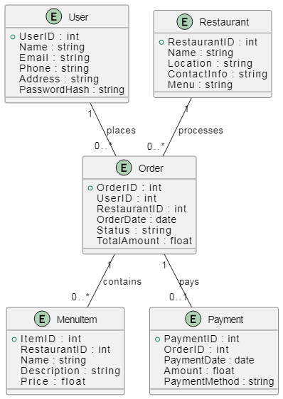
Diagram:

Entity-Relationship Diagram (ERD)

Class Diagram
Purpose: The class diagram illustrates the system’s classes, their attributes, methods, and relationships, depicting the object-oriented structure.
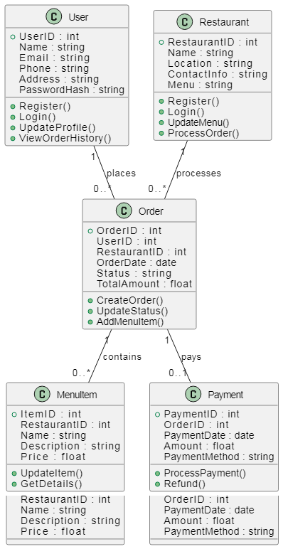

Class Diagram
Description:
- User class with methods for registering, logging in, updating profiles, and viewing order history.
- Restaurant class with methods for registering, logging in, updating the menu, and processing orders.
- Order class with methods for creating orders, updating statuses, and adding menu items.
- MenuItem class with methods for updating items and getting details.
- Payment class with methods for processing payments and refunds.

Sequence Diagram:
Purpose: The sequence diagram shows the interaction between different components or objects in a specific scenario, detailing the sequence of messages exchanged.
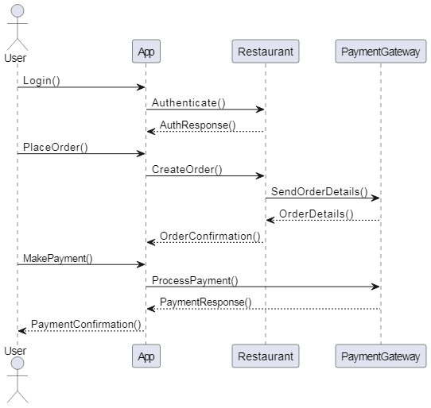
Scenario: Placing an Order

Sequence Diagram
Description:
- Login: User logs in, and the App authenticates with the Restaurant.
- Place Order: User places an order; the App creates the order with the Restaurant.
- Payment: User makes a payment; the App processes the payment with the Payment Gateway.
These diagrams provide a comprehensive view of the system’s structure, interactions, and data relationships, which is crucial for understanding and developing the YUM app.

Design Models

Component Diagram
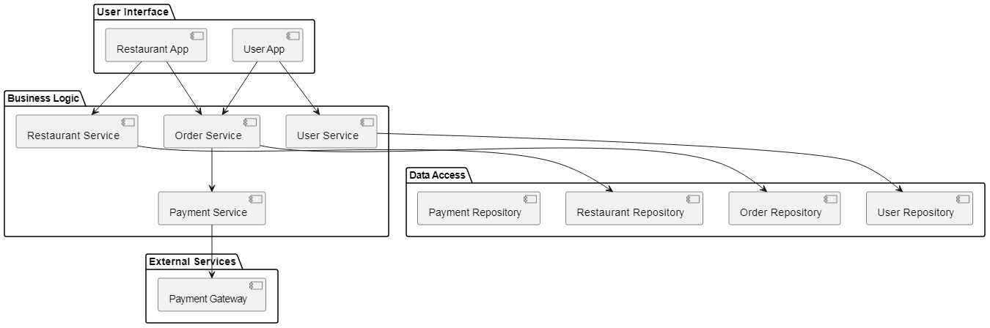
Purpose: The component diagram shows the high-level components of the system and their interactions. It provides a view of the software architecture, detailing the organization and dependencies between components.
Component Diagram
Description:
- User Interface: Includes User App and Restaurant App that interact with the business logic components.
- Business Logic: Contains services such as Order Service, User Service, Restaurant Service, and Payment Service.
- Data Access: Includes repositories for managing data persistence, such as Order Repository, User Repository, Restaurant Repository, and Payment Repository.
- External Services: The Payment Gateway is an external component used by the Payment Service for processing payments.

Deployment Diagram
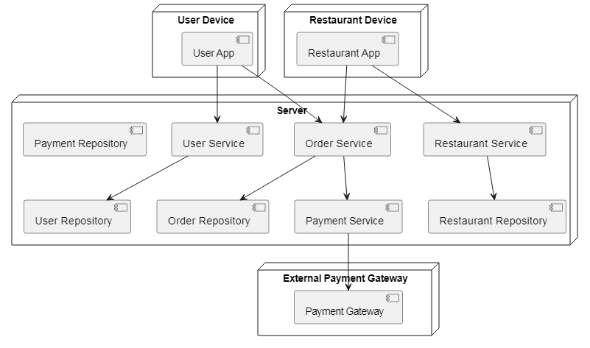
Purpose: The deployment diagram illustrates the physical deployment of artifacts on nodes, showing how software components are distributed across the hardware infrastructure.

Deployment Diagram

Description:
- User Device: Hosts the User App used by end users.
- Restaurant Device: Hosts the Restaurant App used by restaurant staff.
- Server: Contains all core services and repositories, including Order Service, User Service, Restaurant Service, Payment Service, Order Repository, User Repository, Restaurant Repository, and Payment Repository.
- External Payment Gateway: Represents an external service for processing payments, which the Payment Service interacts with.

Screenshots

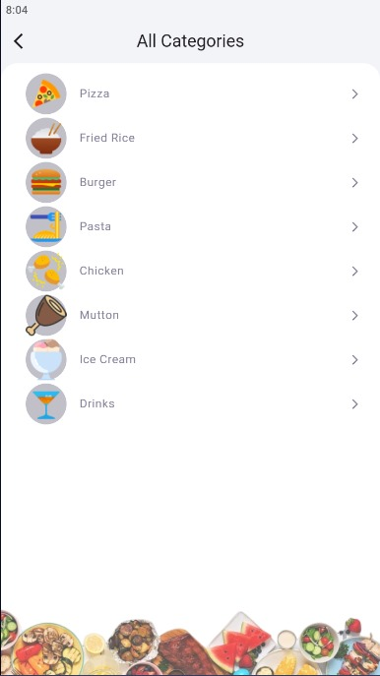
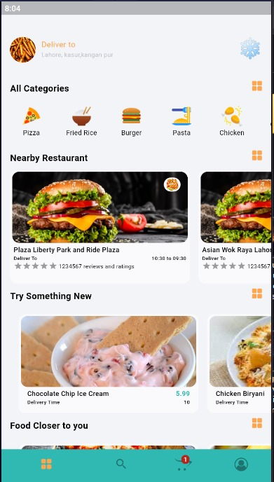
Home Page Categories

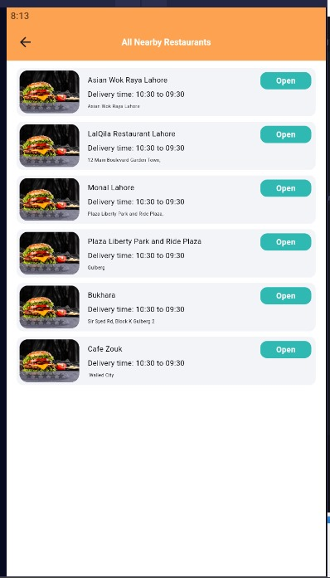
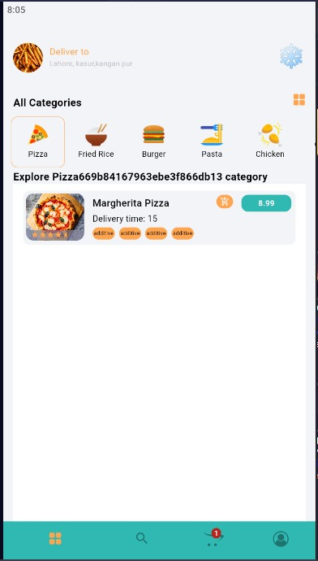

Food by Category on Home Page All Restaurants

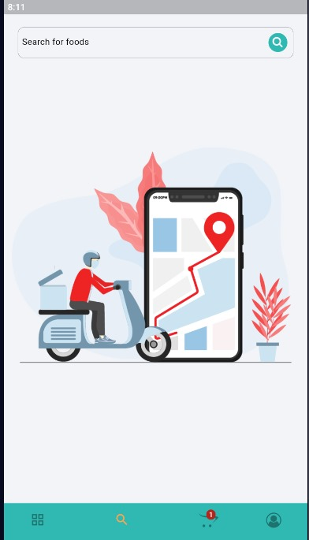
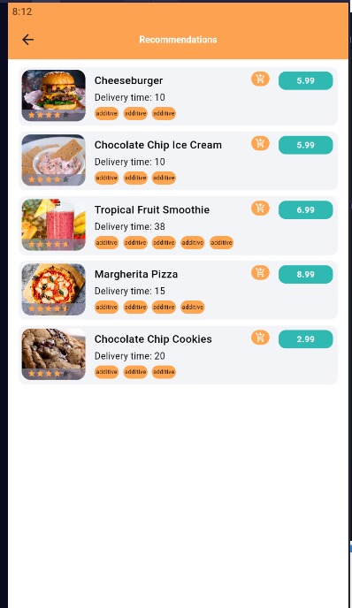

Search Food Page All Recommanded Foods List Page

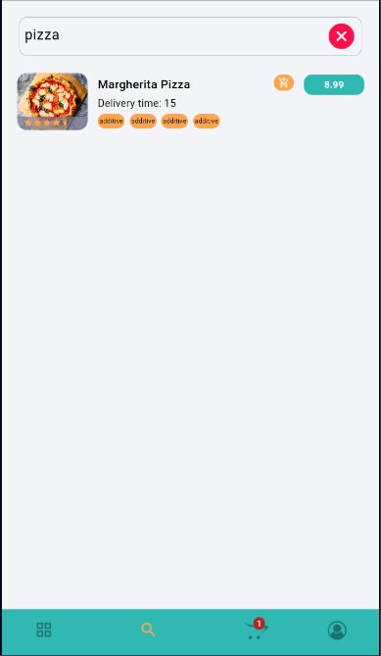
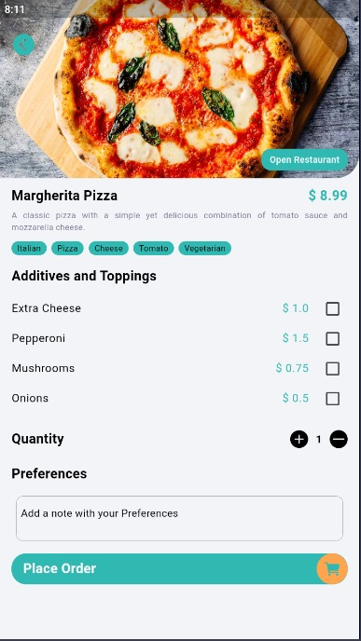

After Search foods list on search Pages Foods Details Page

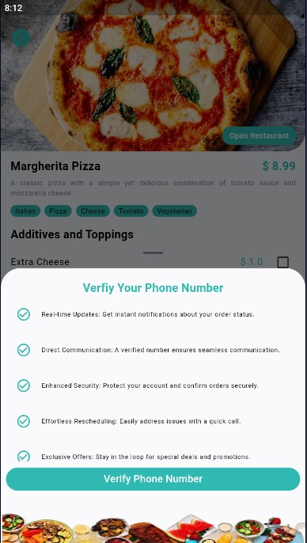
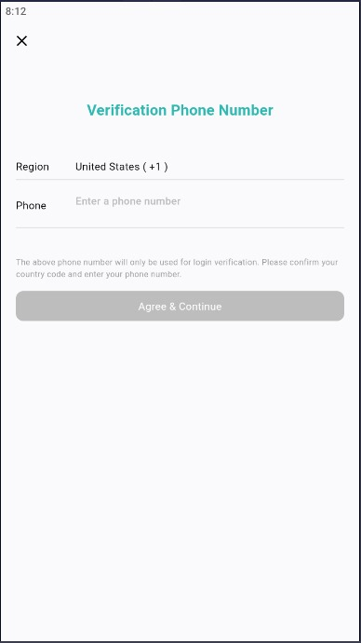

Phone Verification

Test Cases

Test Case 1: User Registration
Identifier | - TC-1
Priority | - High
Related requirements(s) | - Use-Case: Register  - (Functional Requirements: Register)
Short description | - Verify that a new user can successfully register with valid details.
Pre-condition(s) | - User is on the registration page of the app
Input data | - Name: John Doe  - Email: john.doe@example.com  - Phone: +1234567890  - Address: 123 Elm Street, Springfield  - Password: SecurePassword123
Detailed steps | - Open the app and navigate to the registration page.  - Enter the input data into the corresponding fields.  - Click the "Register" button.  - Check for email verification link.
Expected result(s) | - The user should receive a verification email.  - The registration page should display a confirmation message stating that a verification email has been sent.
Post-condition(s) | - User’s details are saved in the database with a pending verification status.

Test Case 2: Login with Correct Credentials
Identifier | - TC-2
Priority | - High
Related requirements(s) | - Use-Case: Login  - SRS Section: 2.2.2 (Functional Requirements: Login)
Short description | - Verify that a registered user can log in with correct credentials.
Pre-condition(s) | - User has already registered and verified their email.
Input data | - Email: john.doe@example.com  - Password: SecurePassword123
Detailed steps | - Open the app and navigate to the login page.  - Enter the input data into the corresponding fields.  - Click the "Login" button.
Expected result(s) | - User is successfully logged in and redirected to the home page.  - The user’s name is displayed on the home page.
Post-condition(s) | - User’s session is active, and they have access to the app’s features.

Test Case 3: Place an Order
Identifier | - TC-3
Priority | - High
Related requirements(s) | - Use-Case: Place Order  - SRS Section: 2.2.4 (Functional Requirements: Place Order)
Short description | - Verify that a user can successfully place an order.
Pre-condition(s) | - User is logged in and has selected items to order.
Input data | - MenuItem ID: 101  - Quantity: 2  - Delivery Address: 123 Elm Street, Springfield
Detailed steps | - Open the app and navigate to the food selection page.  - Select the desired Menu Item and specify the quantity.  - Add the item to the cart.  - Go to the checkout page and confirm the delivery address.  - Click the "Place Order" button.
Expected result(s) | - The order is placed successfully.  - The user receives an order confirmation message.  - The order details are saved in the database and displayed in the order history.
Post-condition(s) | - Order is created in the system, and the user’s order history is updated.

Test Case 4: Payment Processing
Identifier | - TC-4
Priority | - High
Related requirements(s) | - Use-Case: Make Payment  - SRS Section: 2.2.5 (Functional Requirements: Make Payment)
Short description | - Verify that a user can successfully make a payment for an order.
Pre-condition(s) | - User has placed an order and is on the payment page.
Input data | - Payment Method: Credit Card  - Card Number: 1234 5678 9012 3456  - Expiry Date: 12/25  - CVV: 123
Detailed steps | - Open the app and navigate to the payment page.  - Enter the payment details into the correspondingfields.  - Click the "Make Payment" button.
Expected result(s) | - Payment is processed successfully.  - The user receives a payment confirmation message.  - The payment details are saved in the database.
Post-condition(s) | - Payment is recorded, and the order status is updated to reflect the payment.

Test Case 5: View Order History
Identifier | - TC-5
Priority | - Medium
Related requirements(s) | - Use-Case: View Order History  - SRS Section: 2.2.10 (Functional Requirements: View Orders and History)
Short description | - Verify that a user can view their order history.
Pre-condition(s) | - User is logged in and has placed one or more orders.
Input data | - None
Detailed steps | - Open the app and navigate to the user account page.  - Click on the "Order History" link.
Expected result(s) | - The user is shown a list of their past orders.  - Each order displays details such as order date, items, and status
Post-condition(s) | - User’s order history is visible and correctly reflects past orders.

